7374 Group 20 Project Findings

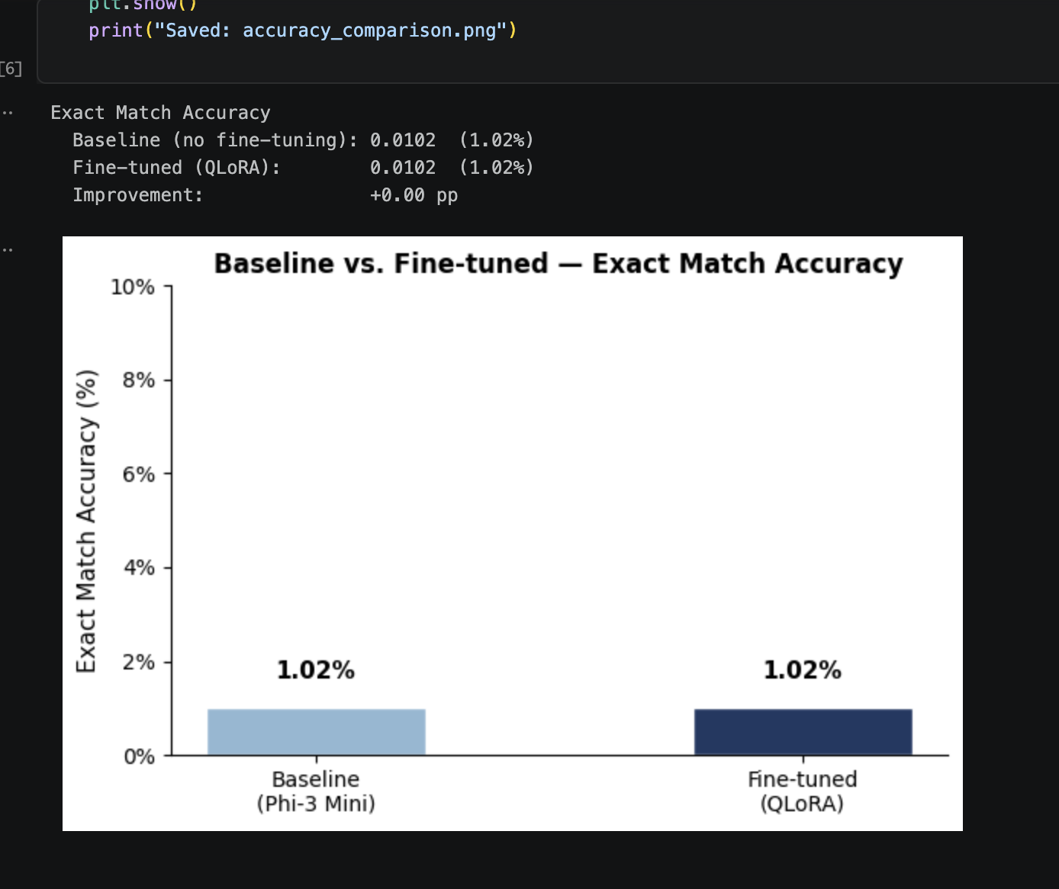
From the above diagram, the baseline model and fine-tuned models archived the exact same level of accuracy points to a key observation -- that the training was on the inexact instructions rather than a model failure. To mitigate this, we might want to back trace our steps, one possible explanation is that the models were instructed by incorrect instructions. We will report back of the findings in the next update.

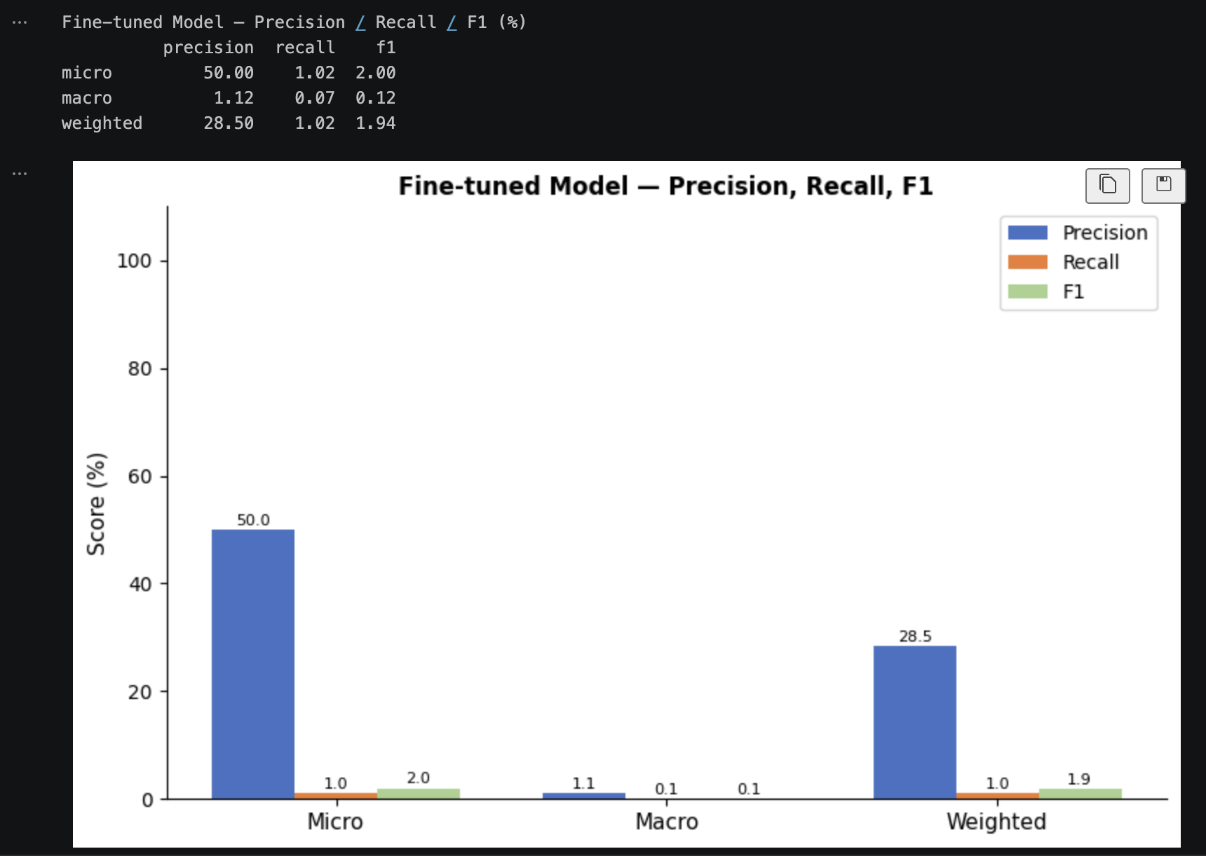
From the above diagram, we can see that there is a high precision / low recall gap, which indicates the model is learning the correct skills concepts but the evaluation pipeline needs output normalization. This in itself is a NLP engineering challenge. We will attempt to identify ways to mitigate this in the next update. If time constrain exists, a propersed solution will be included; and if time allows, an implantation of the proposed solution will be utilized.

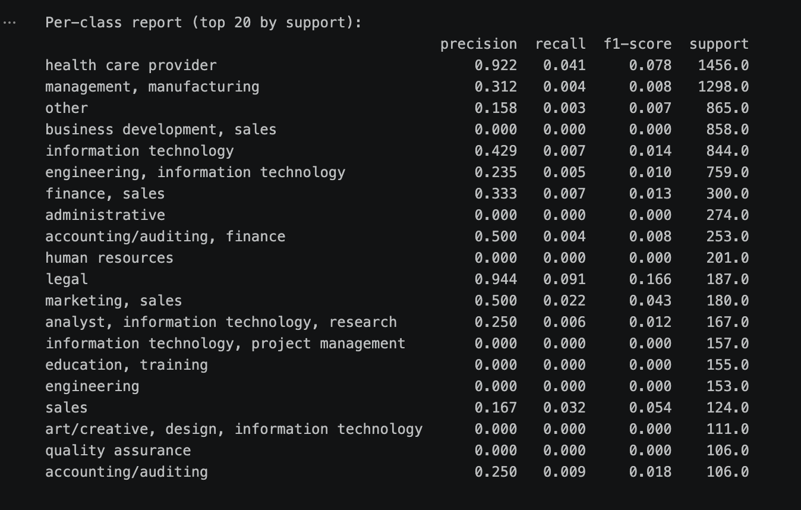
The above, per-class report, is worth reading:
Legal and health care provider jobs has over 90 per cent precision, our model has learned and mastered the skills for these job categories, well done. It proves our fine-tune has worked.
However, recall is persistently low, coming back to our prevous conclustion, our models has learned the core concepts but is not reflecting well on the recall scores. The model is generating many words but mostly miss the exact pharses. One example would be “sales and business development” but with a comma, things changed to “business development, sales”.
One way to mitigate this is to include a fuzzy matching layer, and I believe, with this added, our model will shine with the skills names learned and output.
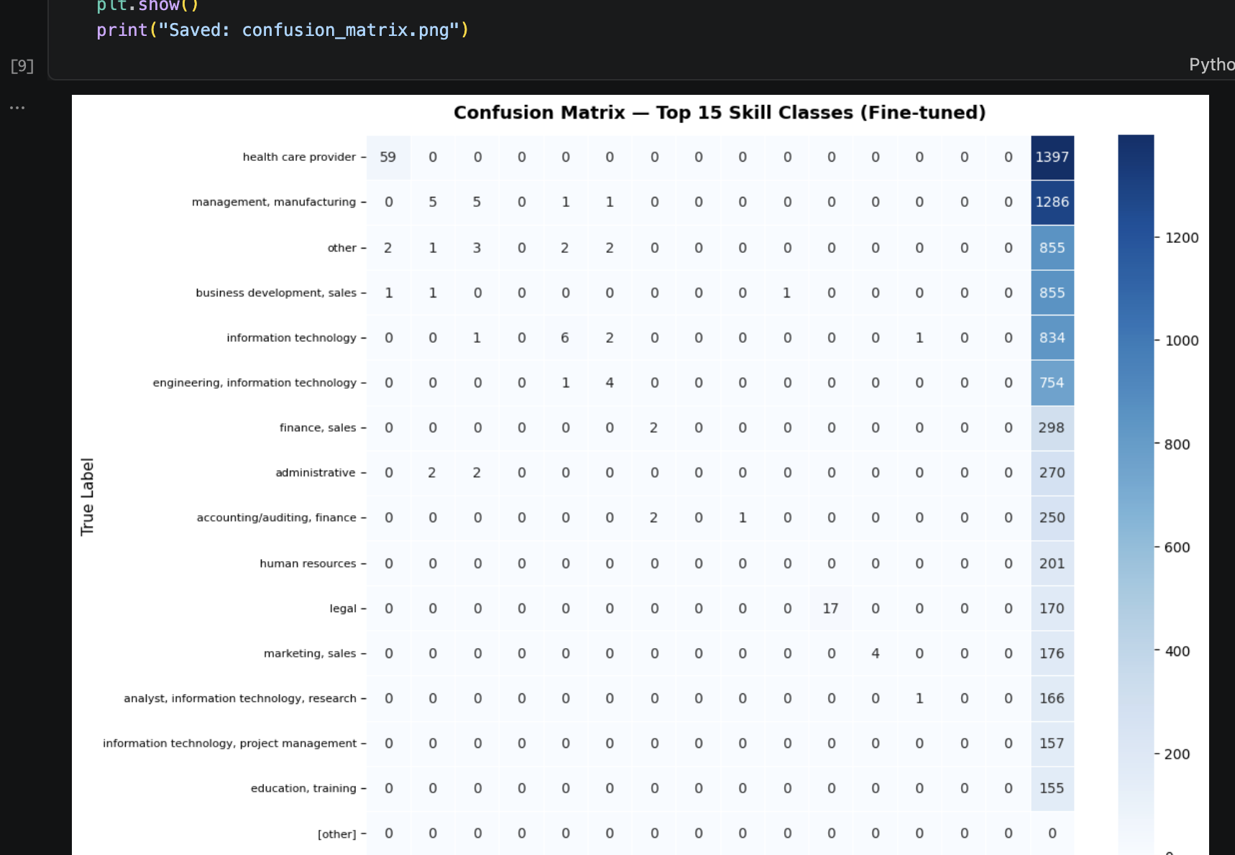
The diagonal is telling us our model is learning the core concepts, one more time. However, based on the other category, the problem lies with the output, our model is just not hitting the right spots. There is a very little cross-class confusion, this is indicting good learning from the model but once again, the problem lies with the output. A potential mitigation is to re-run inference with a smarter output parser that handles verbose outputs.
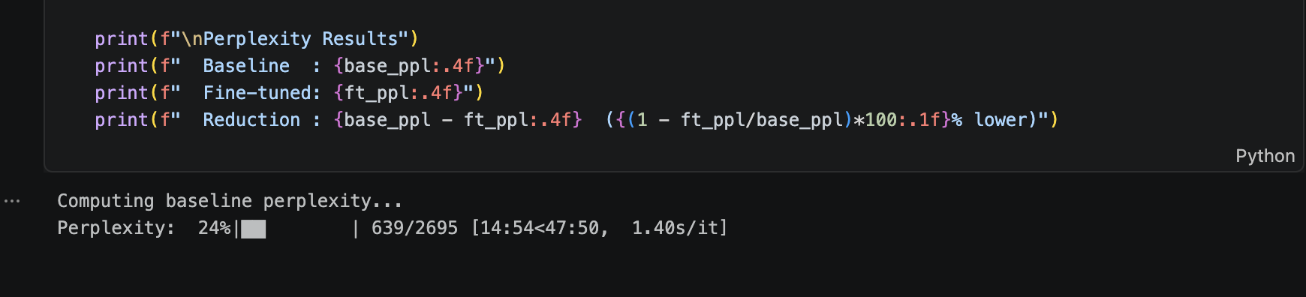
Kaggle notebook crashed at 24% training on Perplexity. Free available GPU resources are slow and inconsistent. The course, with a heavy euphemizes on model training should implement easier-to-adopt high power GPU computing cores that is compatible with more niche models, such as Microsoft Phi-3 models in our case. Without a reliable way to get computing power, it puts our project at a disadvantage but we are mitigating to the best of our abilities and this has been a good learning experience so far.

